# **Name: Abdurrahman Qureshi**

# **Roll No: 210451**

Practical No: 17

**1) Execute the following code**

**Sender:**

import java.net.*;

public class EX17Q1A {

public static void main(String args[])throws Exception{

DatagramSocket ds = new DatagramSocket(3000);

byte[] buf = new byte[1024];

DatagramPacket dp = new DatagramPacket(buf, 1024);

ds.receive(dp);

String str = new String(dp.getData(), 0, dp.getLength());

System.out.println(str);

ds.close();}}

**Receiver:**

import java.net.*;

public class EX17Q1B {

public static void main(String args[])throws Exception{

DatagramSocket ds = new DatagramSocket();

String str = "Java is Easy!!!!!!!!";

InetAddress ip = InetAddress.getByName("127.0.0.1");

DatagramPacket dp = new DatagramPacket(str.getBytes(), str.length(), ip, 3000);

ds.send(dp);

ds.close();}}

**OUTPUT:**

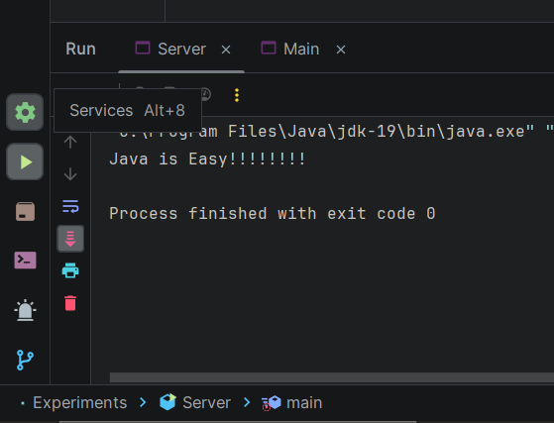

**2) Write a program using DatagramPacket and DatagramSocket to create chat application**

**CODE:**

**Sender:**

import java.io.*;  
import java.net.*;  
class Main{  
 public static DatagramSocket *clientsocket*;  
 public static DatagramPacket *dp*;  
 public static BufferedReader *dis*;  
 public static InetAddress *ia*;  
 public static byte *buf*[] = new byte[1024];  
 public static int *cport* = 789, *sport* = 790;  
 public static void main(String[] a) throws IOException{  
 *clientsocket* = new DatagramSocket(*cport*);  
 *dp* = new DatagramPacket(*buf*, *buf*.length);  
 *dis* = new BufferedReader(new  
 InputStreamReader(System.*in*));  
 *ia* = InetAddress.*getLocalHost*();  
 System.*out*.println("Client is Running... Type STOP to Quit");  
 while(true) {  
 String str = new String(*dis*.readLine());  
 *buf* = str.getBytes();  
 if(str.equals("STOP")) {  
System.*out*.println("Terminated...");  
 *clientsocket*.send(new  
 DatagramPacket(*buf*,str.length(), *ia*,  
 *sport*));  
 break; }  
 *clientsocket*.send(new DatagramPacket(*buf*,  
 str.length(), *ia*, *sport*));  
 *clientsocket*.receive(*dp*);  
 String str2 = new String(*dp*.getData(), 0,  
 *dp*.getLength());  
 System.*out*.println("Server: " + str2); }  
 }  
}

**Receiver:**

import java.io.*;  
import java.net.*;  
class Server{  
 public static DatagramSocket *serversocket*;  
 public static DatagramPacket *dp*;  
 public static BufferedReader *dis*;  
 public static InetAddress *ia*;  
 public static byte *buf*[] = new byte[1024];  
 public static int *cport* = 789,*sport*=790;  
 public static void main(String[] a) throws IOException{  
 *serversocket* = new DatagramSocket(*sport*);  
 *dp* = new DatagramPacket(*buf*,*buf*.length);  
 *dis* = new BufferedReader  
 (new InputStreamReader(System.*in*));  
 *ia* = InetAddress.*getLocalHost*();  
 System.*out*.println("Server is Running...");  
 while(true) {  
 *serversocket*.receive(*dp*);  
 String str = new String(*dp*.getData(), 0,  
 *dp*.getLength());  
 if(str.equals("STOP")){  
System.*out*.println("Terminated...");  
 break; }  
 System.*out*.println("Client: " + str);  
 String str1 = new String(*dis*.readLine());  
 *buf* = str1.getBytes();  
 *serversocket*.send(new  
 DatagramPacket(*buf*,str1.length(), *ia*, *cport*)); }}}

**OUTPUT:**

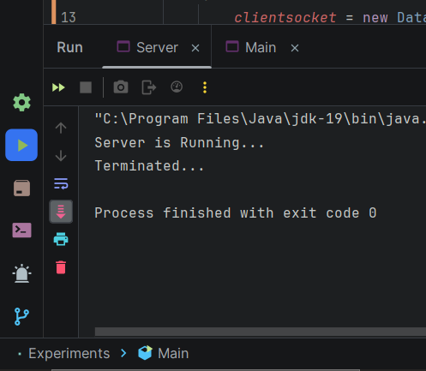 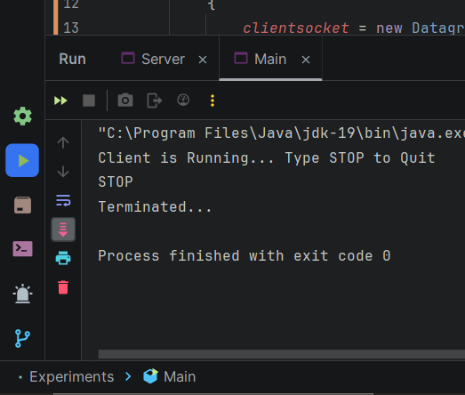

**3) Write a program using DatagramPacket and DataGramSocket to copy the contents of one file into other**

**CODE:**

**Sender:**

import java.net.*;  
import java.io.*;  
public class Server  
{  
 public static void main(String args[])throws IOException  
 {  
 byte b[]=new byte[3072];  
 DatagramSocket dsoc=new DatagramSocket(1000);  
 FileOutputStream f=new FileOutputStream("D:\\Diploma''SEM 5''AJP''Experiments''PQR.txt");  
 while(true)  
 {  
 DatagramPacket dp=new DatagramPacket(b,b.length);  
 dsoc.receive(dp);  
 String str = new String(dp.getData(),0,dp.getLength());  
 System.*out*.println(str);  
 byte c[]=str.getBytes();  
 f.write(c);  
 f.close();  
 System.*out*.println("success...");  
 }}}

**Receiver:**

import java.net.*;  
import java.io.*;  
public class Main  
{  
 public static void main(String args[])throws Exception  
 {  
 byte b[]=new byte[1024];  
 FileInputStream f=new FileInputStream("D:\\Diploma''SEM 5''AJP''Experiments''ABC.txt");  
 DatagramSocket dsoc=new DatagramSocket(2000);  
 int i=0;  
 while(f.available()!=0)  
 {  
 b[i]=(byte)f.read();  
 i++;  
 }  
 f.close();  
 dsoc.send(new DatagramPacket(b,i,InetAddress.*getLocalHost*(),1000)); }}

**OUTPUT:**

